HALLOWEEN
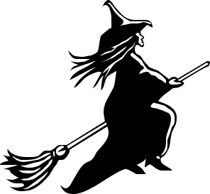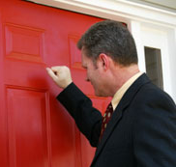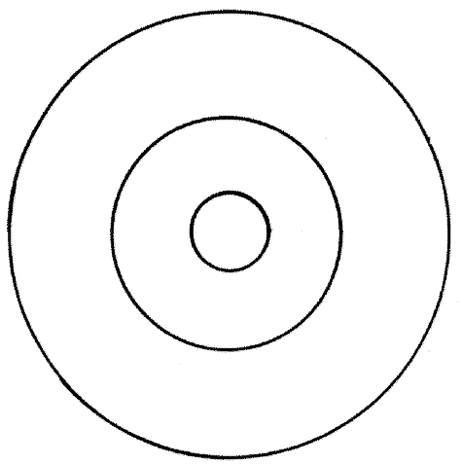
_ _ _ _ _ _ _ _ _ _ _ _ _ _ _ _ _ _ _ _ _ _ _ _ _ _ _ _ _ _ _
Naloga ima več ravni. Vpisati moraš kaj je na slikah, vpisati moraš manjkajoče besede v besedilu (na črtkane črte v besedilu. Uporabi besede iz okvirčka), pripisati primerne podnaslove (pred podnaslov vpišeč črko odstavka), poiskati sinonime in prevode ter rešiti križanko.
house / home / fire / for / fun / faces / Evening / November / not / sun / summer / stone / rubber / Scots / run
A "Trick or Treat!" shout little witches, paper-bagged goblins, _ _ _ _ _ _-masked monsters and bed-sheeted ghosts as they give a bag for candy. It is October and it's Halloween time! Today, Halloween is a festival of _ _ _ for kids. An occasion to dress up as little monsters, ghosts or witches. Over time the custom of adults dressing up as demons changed and the children took over. As they went from _ _ _ _ _ to house they would knock at each house and cry "trick or treat". People would then give the children apples or buns and later candy to keep from being tricked.
B Halloween is celebrated on the _ _ _ _ _ _ of October 31st, which is the evening before the Christian All Saint's Day. Halloween's history goes back to the ancient religion of the Celtic tribes (circa 500 B.C.) from whom came the Britons, _ _ _ _ _ and the Irish. Present day Britains, Scots, Welsh and Irish are all descendants from these ancient Celtic tribes.
C The Celts worshipped nature and believed in the spirits. They worshipped over 300 gods. Their chief god was the sun and they celebrated two festivals revolving around the sun: Beltane, to mark the beginning of _ _ _ _ _ _ and Samhain or Saman to mark the start of winter. The Celts believed that at the end of summer, Samhain, the lord of death becomes powerful and overpowers the sun god. On October 31, Samhain assembles all the evil spirits who had died last year and lets them come _ _ _ _ to visit the living.
D On October 31, after the harvest, the druids would meet under an oak grove or near large _ _ _ _ _ circles where they performed sacrifices. Stonehenge in England is one such druid circle. The priests would light great fires and offer sacrifices to Samhain to ensure that the _ _ _ returned after the winter. During the night all fires except the sacrificial one to Samhain were turned out. The Vigil of Samhain, as it was called, would keep the sacrificial _ _ _ _ on through the night and the next day they would light the fire from the sacrificial fire in each household.
E Villagers would leave food and nuts for the spirits, who come _ _ _ a visit. If the demon was happy with the treat, it would _ _ _ trick the person or cast an evil spell. This is the origin of the present day trick or treat. Traditionally people duck for apples in a tub of water and use hollowed-out pumpkins lit by candles which scare away evil spirits. Legend has it that people would also wear masks and blacken their _ _ _ _ _ so the spirits would not see them. They believed that ghosts or spirits cannot see their own reflection. So, if a demon saw another creature looking horrible, they would _ _ _ away in terror.
F In 834 A.D., Pope Gregory III moved the festival of All Saints Day, then celebrated on May 13 to _ _ _ _ _ _ _ _ 1. The new day was called All Saints Day or Hallowmas. Thus, the evening and night before it became All Hallow's eve and later Halloween.

PODNASLOVI - v okvirček vpiši črko odstavka
THE ORIGIN TRADITIONS THE FIRE CHRISTIAN FESTIVAL

TODAY SUN FESTIVALS

SOPOMENKE – vpiši odgovarjajočo številko
1 | Dress up |  | offering
2 | blacken |  | habit
3 | overpower |  | adore
4 | ancient |  | Wear masks
5 | custom |  | Paint black
6 | sacrifice |  | Very old
7 | worship |  | win

PREVEDI - vpiši odgovarjajočo številko
1 | saint |  | škrat
2 | pope |  | urok
3 | spell |  | žemlja
4 | tub |  | žetev
5 | goblin |  | svetnik
6 | bun |  | izdolben
7 | harvest |  | papež
8 | Hollowed out |  | kad

KRIŽANKA- POIŠČI BESEDE V PREBRANEM BESEDILU Črke – vodoravno, števila - navpično
A – Scots and Welsh are ________ of Celtic tribes , B – who left out food for ghosts, C – to wear something is to _______ up, D – trick or _________;
1 – people who performed sacrifices, 2 – children get these on Halloween instead of apples, 3 – what ghost masks are made of, 4 - Samhain is the lord of this
 |  | 1
 | A
 |  |  |  |  | 2
 |  |  |  |  |  |  |  |  | 3 |  | 4
B
 |  |  |  |  |  | C
 |  |  |  |  |  | D

