

**Do or do not. 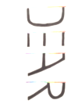 is no try.**

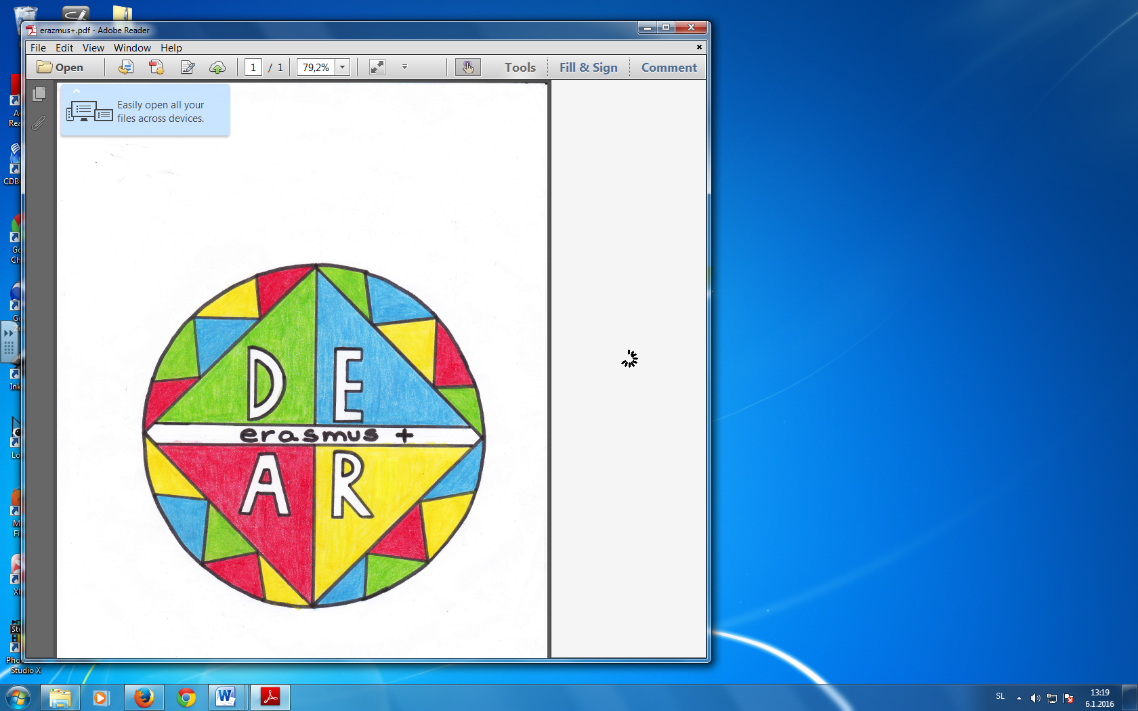

**Developing English through ARt oriented activities**