Link to the thesaurus: http://www.thesaurus.com/
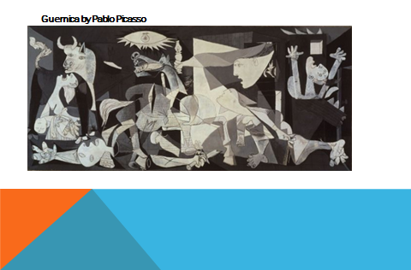

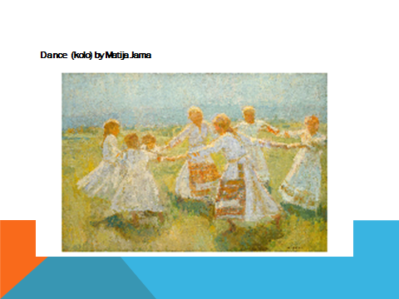
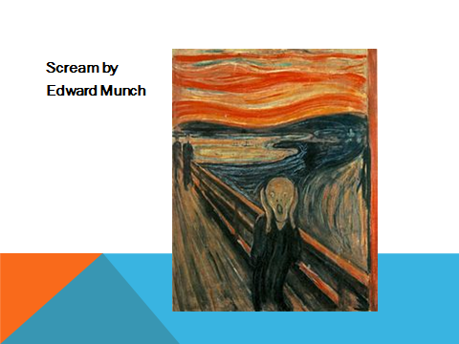

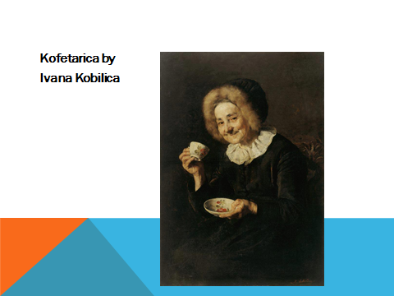

POEM

When I'm depressed I cry,
When I'm happy I smile,
When I'm tired I just fall asleep.
When I'm anxsious I clean,
When I'm afraid I grit my teeth,
When I'm serene, I drink some coffee.

Find emotions.
Which one is not an emotion?
What is it? – feeling
Find the verbs.
Change the verbs. What do you do when you are happy, nervous…
Change the emotions – Read your poem.

