- SENSES:
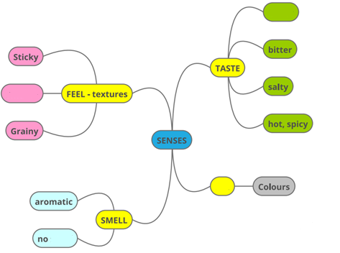
a. Complete the map:
b. Translate the words:
c. Give examples of food which is ______:
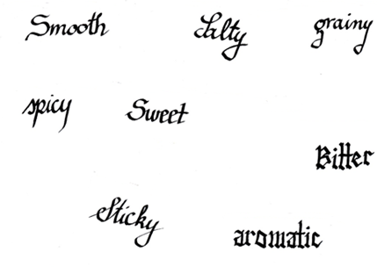

FOOD | FEEL - TEXTURE | SMELL | TASTE | SEE - COLOUR
VANILLA SUGAR
CINNAMON
HONEY
FLOUR
SALT
COCOA POWDER
BUTTER
- WHAT IS THE FOOD LIKE?
Fill in all the cathegories.

- PREPARE TO REPORT
e.g. Vanilla sugar is grainy and it is aromatic. It tastes sweet. It is white. Flour does not have a smell.
- CALLIGRAPHY:
  - Did you notice how many different ways there are to write the letter »s«?
  - Select one word and practice writing it on the paper. Then you will write it on the gingerbread biscuit.
