FEELINGS - VOCABULARY

Categorize the feelings as positive, negative or neutral

POSITIVE | NEGATIVE | NEUTRAL

amazed serene distressed vibrant solitary suprised relaxed miserable desperate compasionate delighted
radiant bothered annoyed dissatisfied upset worried furious depressed neglected agitated weary tense composed

ADJECTIVES IN –ED / -ING:
Adjectives in –ed – How do you feel? I am depressed / annoyed / delighted…
Adjectives in –ing – How something else feels: It is annoying / bothering / relaxing…

Finish the sentences:
__________
__________
(amaze): I was by the news. The view from the top is .
____
_____
(relax): This music is . People seem .

__________
(agitate): The dog seems by something. This barking is

Architecture monument (name, coutry, continent)  Use the line below | What is in the picture? | The color which describes your feeling at looking at the picture. | How do you feel by the picture?
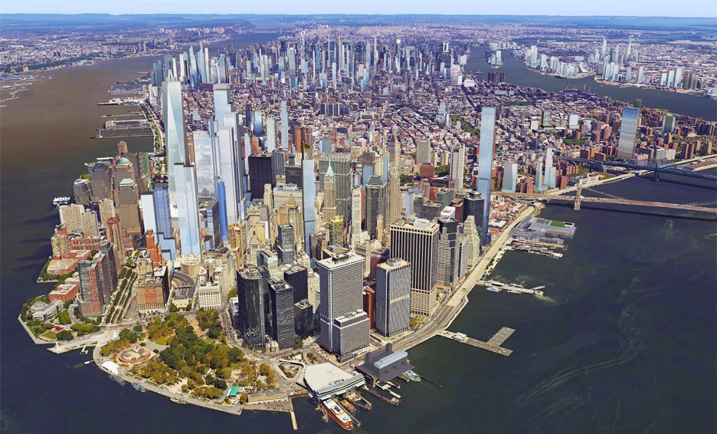

Architecture monument (name, coutry, continent)  Use the line below | What is in the picture? | The color which describes your feeling at looking at the picture. | How do you feel by the picture?
